**Step-1**:-Created Two Virtual networks with Central US and West US Region with two subnets in each Vnet one subnet is for VMs and another subnet is for Application Gateway.

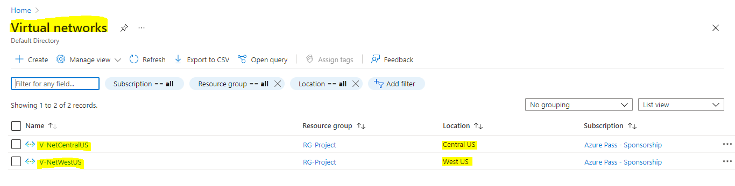

**Step-2**:-Created Two VMs on Central US (VM1 & VM2), Two VMs on West US (VM3 & VM4) with the respective Vnets Created. These VMs needs to run on Linux.

(VM-1 & VM-3=Upload page)

(VM-2 & VM-4=Home page)

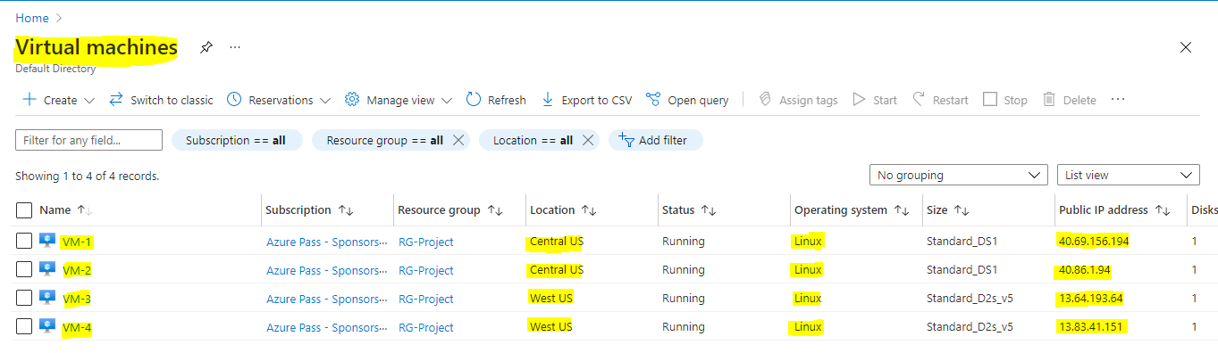

**Step-3**:-We have to create one Storage Account for host the **error page** for that Data management>Static Website>enable>error document path>give the name of error.html file name>save>we will get the URL.

And we have to create one Container to upload the error.html file and whatever files we upload on the VM-1 and VM-3 it will store in this Container.

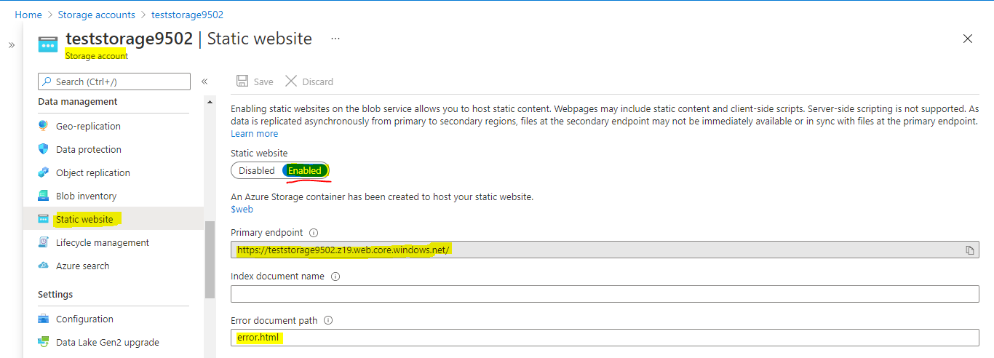

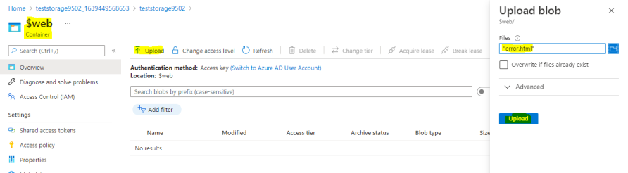

Created one container to keep all the codes in that container

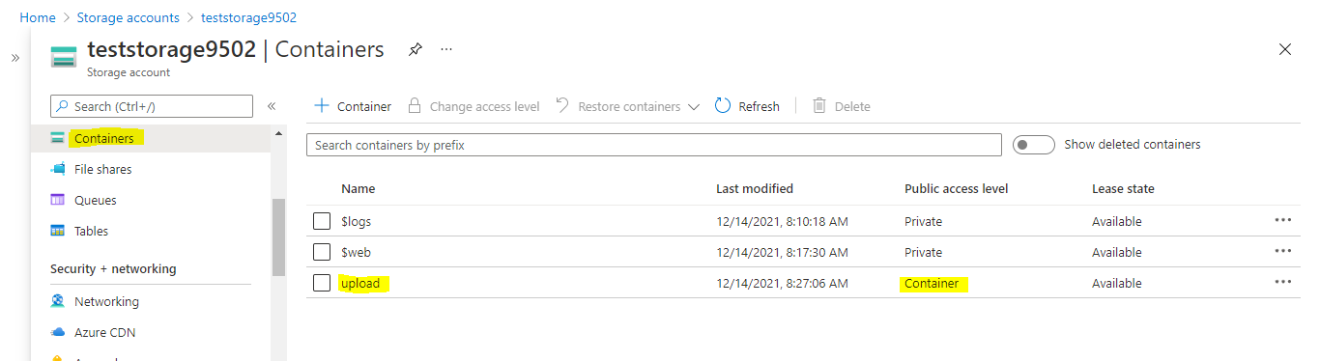

**Step-4**:- Create an Application Gateway.

We have to give basic details in first step

We have to create new IP address in Frontends

We have to create two different pools for two VMs in backend pools because we are hosting two different pages on VMs

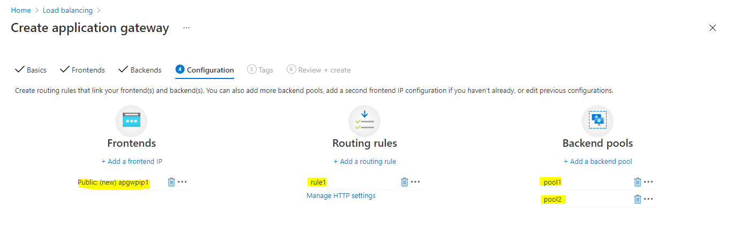

We have to provide the URL which we get on storage account on add a routing rule>Listener>error page url>paste that URL with an extension of /error.html

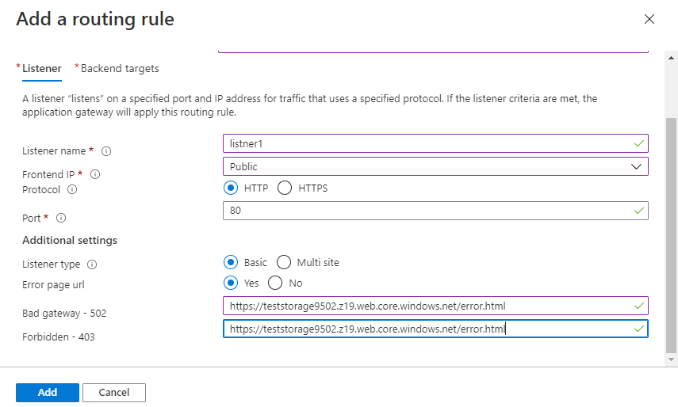

We have to give pool2 (VM-2) as a Backend targets as it is **HOME PAGE** and in path based Routing we have to give pool1 (VM-1) as it is **UPLOAD PAGE.**

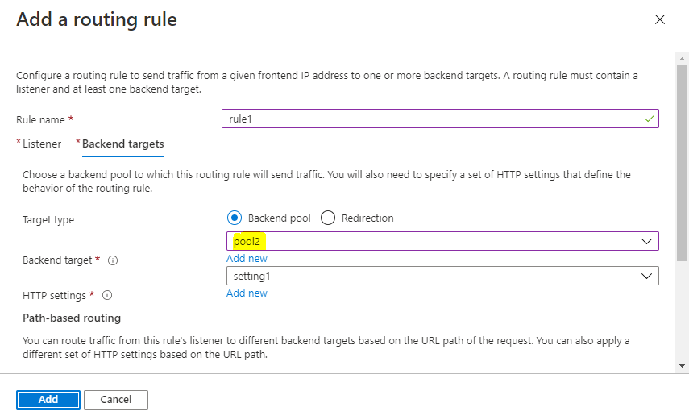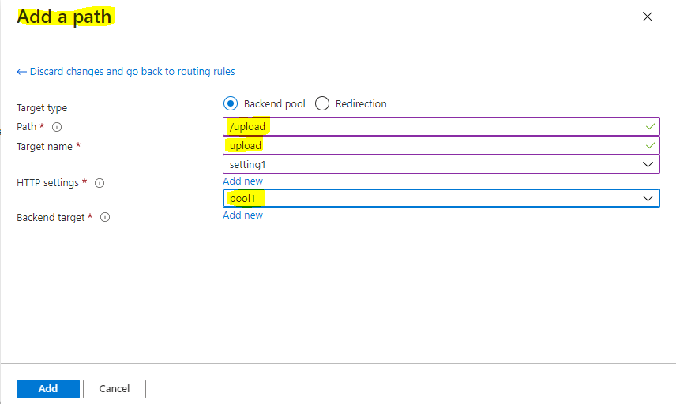

We have follow the same steps for Application Gateway 2 also

Two application gateways have been created

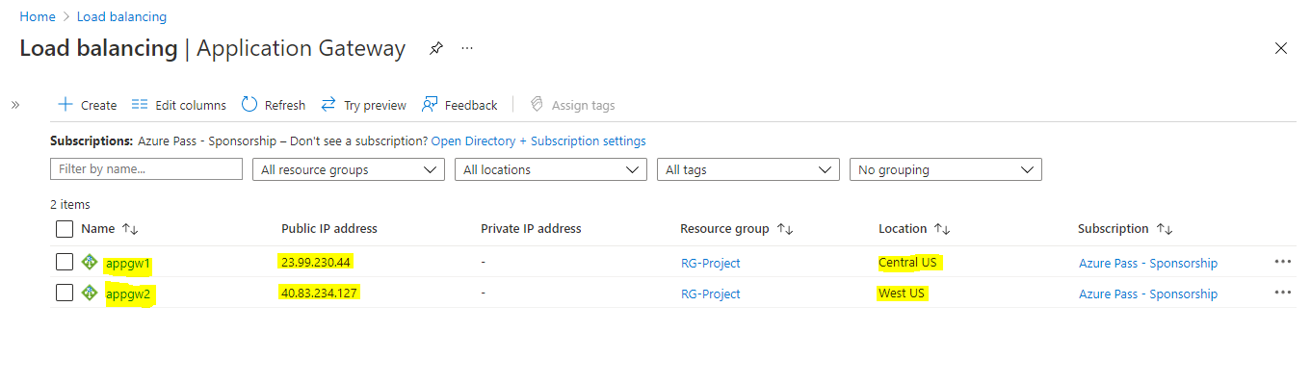

**Step-5**:-Now we have to host the HOME PAGE on VM2 and VM4

On VM first we have update the machine (**sudo apt-get update**)

Second we have to clone the codes from git hub to the machine (**sudo git clone “link of git hub”**)

Give **ls** and check the content on the git hub

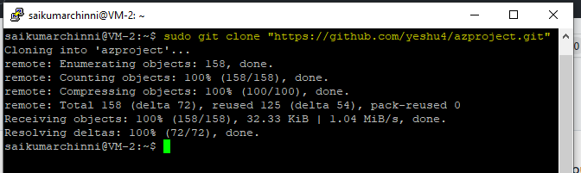

To enter into that **azproject** directory we have to give **cd azproject/**

List of code files on **azproject**

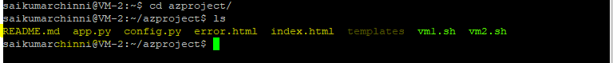

We have the home page code on the vm2.sh file so we have to host that file for that we have to give **./vm2.sh**



We have to repeat the same steps on **VM4** for hosting the home page.

**Step-6**:- Now we have to host the **UPLOAD PAGE** on VM1 and VM3

We have to follow the same steps which we followed on the VM2 and VM4 but we have to select the different code to host **vm1.sh**

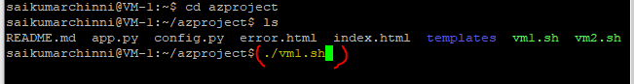

On VM1 and VM3 we have configure the storage account which we created because whatever files we are going to upload in VM1 and VM3 they required storage account for that we have deploy the code **config.py** (**sudo nano config.py**) and provide the details of storage account.

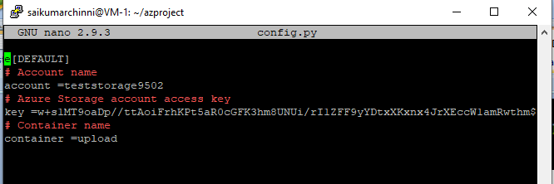

After that we have deploy the python code (**app.py**)

(**sudo python3 app.py**)

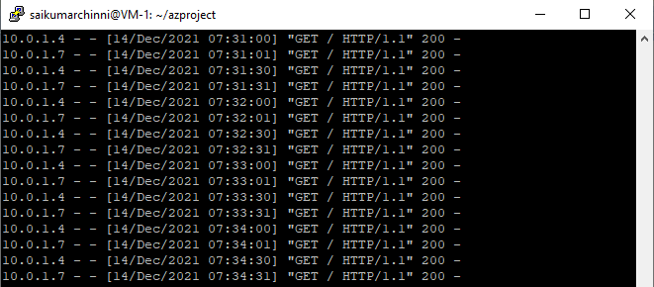

Follow the same steps on VM-3

**Step-7**:- Now we have to create Traffic Manager Profile

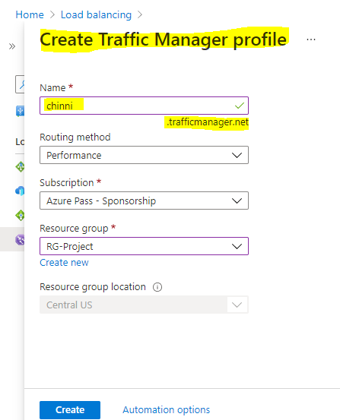

Now we have to add our 2 Application gateways to the Traffic Manager as endpoints, basically traffic manager is a DNS based load balancer so whatever endpoints which we are going to add on traffic manager are also need to be DNS configured.

See it is showing DNS is not configured Now it is configured after DNS

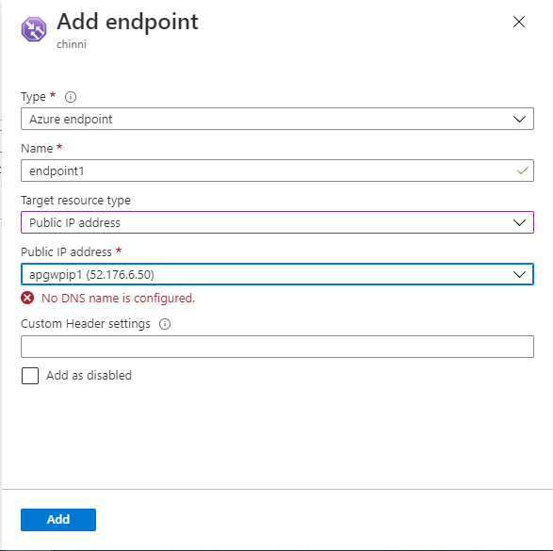 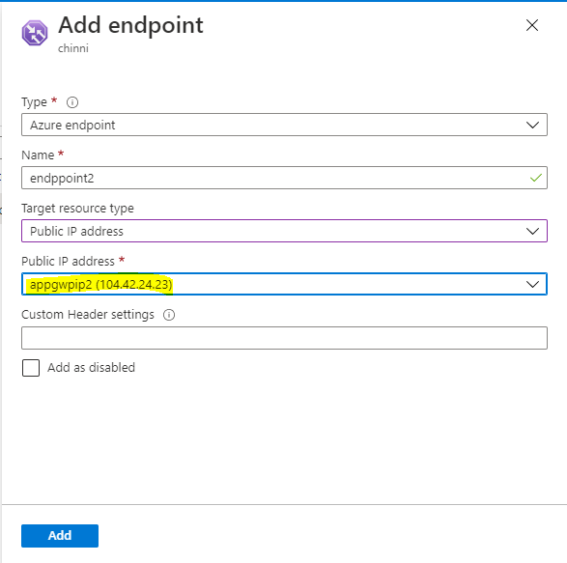

To configure the DNS go to Application gateway>click on frontend ip>configuration>give the DNS label name>save it.

Endpoints are created for 2 application gateway

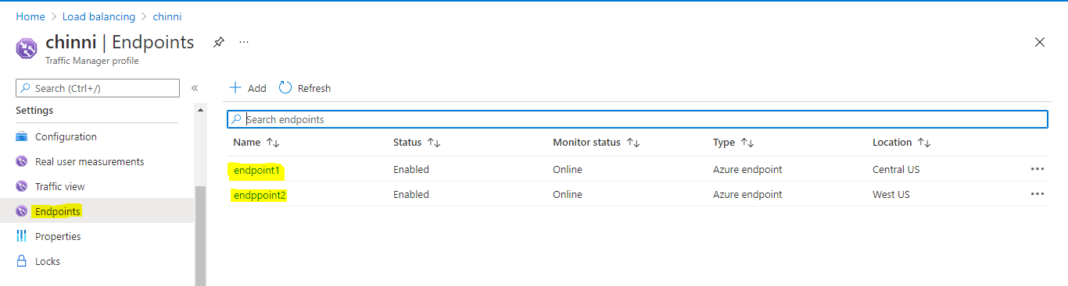

After we have to copy the DNS URL from Traffic manager profile and paste it browser we can see

**HOME PAGE**

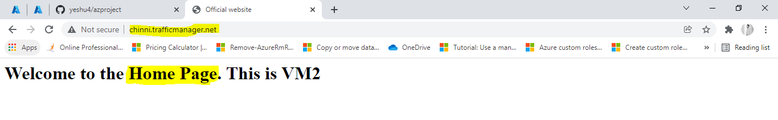

Now we can give the extension for path based routing **/upload** for

**UPLOAD PAGE**

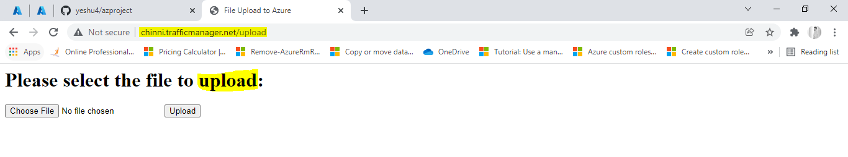

Now if we upload any files in this we can see those in storage account.

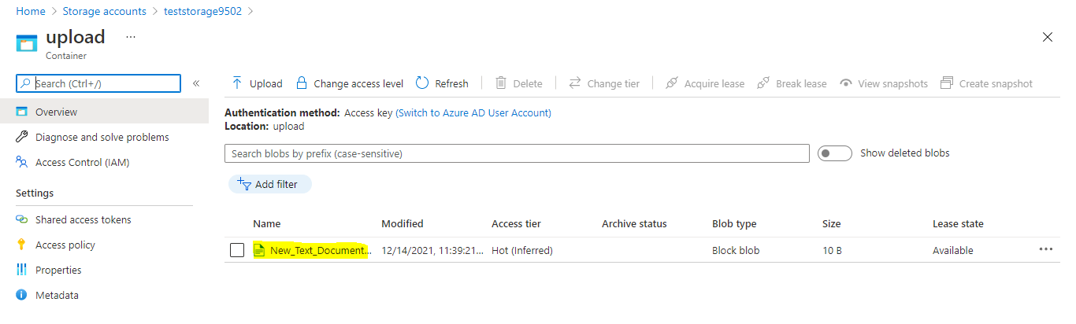

Now if we want to check whether on which VM is working for this upload we can see on Linux VM

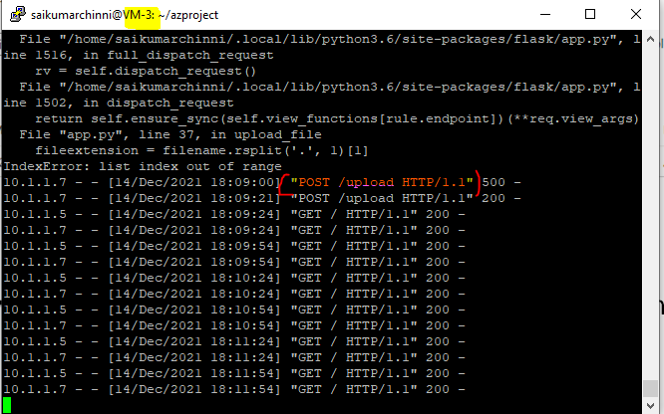

Now if we want to check whether VM-1 is working or not we have disable the VM-3 endpoint from traffic manager.

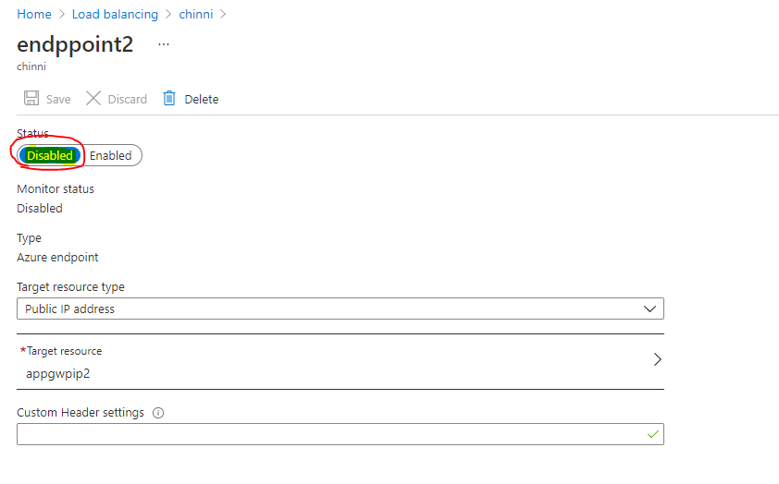

Now if upload anything it will go through VM-1

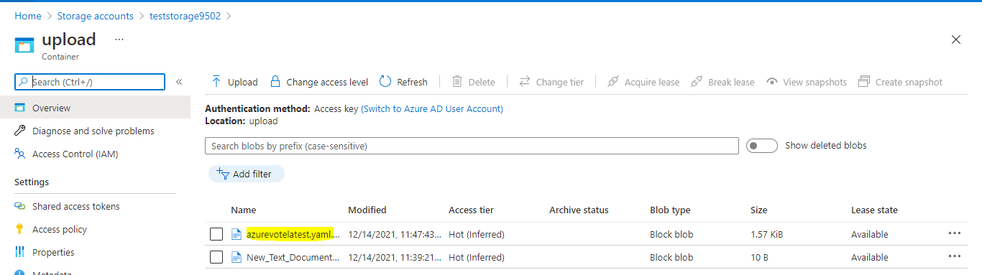

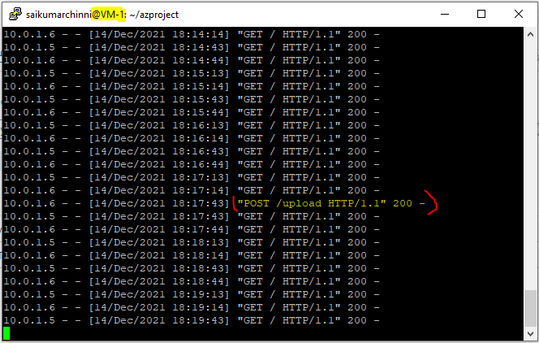

**Step-8**:- We have to create VNet to VNet peering

